

**TASK MANAGEMENT**

**Done by:**

Abeer Ahmad

Roaa AbuTaleb

Shatha Al-Hadad

Roqaiah ALmotawakel

**Supervisor:**

Dr. Hamza Jamel

Content:

System vision . . . . . . . . . . . . . . . . . . . . . . . . . . . . . . . . . . . . . . . . . . . . . . . . . . . . . . . . . . . . .3

Organization Chart . . . . . . . . . . . . . . . . . . . . . . . . . . . . . . . . . . . . . . . . . . . . . . . . . . . . . . . . 4

Keeping Open . . . .. . . . . . . . . . . . . . . . . . . . . . . . . . . . . . . . . . . . . . . . . . . . . . . . . . . . . . . . 5

List of Requirement . . . . . . . . . . . . . . . . . . . . . . . . . . . . . . . . . . . . . . . . . . . . . . . . . . . . . . . . 6

Interview . . . . . . . . . . . . . . . . . . . . . . . . . . . . . . . . . . . . . . . . . . . . . . . . . . . . . . . . . . . . . . . . . 7

Use Case Diagram . . . . . . . . . . . . . . . . . . . . . . . . . . . . . . . . . . . . . . . . . . . . . . . . . . . . . . . . . .9

CRUD Table. . . . . . . . . . . . . . . . . . . . . . . . . . . . . . . . . . . . . . . . . . . . . . . . . . . . . . . . . . . . . . . 13

Use Cases Description. . . . . . . . . . . . . . . . . . . . . . . . . . . . . . . . . . . . . . . . . . . . . . . . . . . . . . . 15

Event. . . . . . . . . . . . . . . . . . . . . . . . . . . . . . . . . . . . . . . . . . . . . . . . . . . . . . . . . . . . . . . . . . . . . 16

Class diagram.. . . . . . . . . . . . . . . . . . . . . . . . . . . . . . . . . . . . . . . . . . . . . . . . . . . . . . . . . . . . . . 17

System vision document:

It’s a system for university departments to help them in tracking the jobs to perform the tasks which contain organize the data and helps to facilitate operation and reduce the cost and reduce the time for the stakeholders.

# System Capabilities:

It is a group of software responsible for managing resources (computer hardware), and computer software, and it represents an intermediary between the user and computer hardware, and by another definition, the operating system represents a bridge to run user programs, and it performs basic tasks such as: managing and allocating computer resources (memory, hard disk, access Peripheral devices, etc...), arranging the priority of handling commands, controlling input and output devices such as the keyboard, as well as facilitating networking, and managing files.

**This system should be capable to:**

1. Create the tables.
2. Entering the grades for the exams and attendees and assignment
3. Create /update /delete reports.
4. collecting and storing information about students
5. handling marks and
6. control adding/deleting subjects

Stakeholders:

They are the people or individuals who have the full authority to carry out the tasks and have a great opinion on the progress of the work. They are also responsible for the progress of the study process within the university and work to develop it and run it in the right way and achieve the desired success.

**Types of stakeholder:**

1. **Internal:** The internal contributors include the dean of the department and the head of the department, and they are the main contributors to the implementation of tasks and finding ideas to solve problems.
2. **External**: External contributors include both lecturers and students, as they are the persons concerned or obligated to carry out the tasks and do whatever is required of them, each according to his work. They also have the full authority to express their opinion and put forward their ideas.
3. **Operational**: Operations carriedout by the actual implementers in the system.
4. **Executive:** They are the actual executors to do the tasks required.

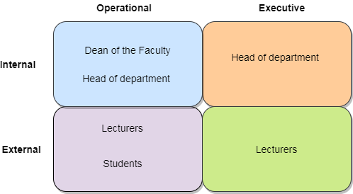

Organization Chart:

A diagram of the organization of jobs among the various departments and their distributions as in the following figure.

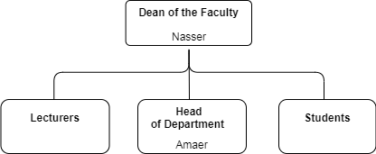

Keeping Open:

|  |  |  |  |  |  |  |
| --- | --- | --- | --- | --- | --- | --- |
| Comment | User contact | Responsible | Target end | Date | Issues Title | ID |
| Sometimes Head of Department need to modify it because some problem that may happened | Student | Amer | Beginning | Before start study | Tables | 1 |
| Sometimes Head of Department need to modify it because some problem that may happened | Amer | Nasser | After four week | Beginning semester | Attendance | 2 |
| Sometimes Head of Department need to modify it because some problem that may happened | lecturers | lecturers | During one week | The end of semester | Class work | 3 |
| Sometimes Head of Department need to modify it because some problem that may happened | Control | lecturers | After one day | After three week | Final exam mark | 4 |

List of Requirement:

## 

It includes those tasks involved in defining requirements or conditions, considering stakeholder requirements, analyzing, documenting, validating, and managing programs, system requirements, or otherwise is an organized set of information that embodies system requirements and contains a set of use cases that describe all interactions. Between the user and the program.

**Type Of Requirement:**

## A) Functional Requirement:

**It’s the activities the system most perform**

1. **Mange tables for the semester**
   * 1. Organizing schedules for lecturers
     2. Organizing schedules for students
2. **Managing student**
3. Manage student' data.
4. Manage attendance, marks, and subject
5. **Managing semester**
6. Finding lecturers for subject
7. provide classrooms for students
8. **managing marks**
9. class work
10. attendance
11. exams

**B) Non-Functional Requirement:**

**It is other system characteristics such as:**

**1. Usability:**

The system will be faster more than manual and can be so easy for users

**2. Reliability:**

The system will notify users about attendance, course work, and final marks at the specific time of delivery.

**3. Security:**

The system will only allow users to use this system to accomplish their tasks, it is not allowed for any of them to consider the tasks and users of others.

1. **Performance:**

The system will design in accuracy and its performance will be good because it will link with strong data present in SQL and for this, it will be able to obtain the information accurately, correctly, and in the required time

Interview

**A summarization of the interview's place and time, the questions asked and any further interviews to conduct if needed**

|  |
| --- |
| Discussion and interview Agenda |
| Setting:  Objective of interview  Understand the procedures related to attendance, coursework and final mark for student.  Date, Time and location :  March 15, 2021, at 11:00AM in Engineering department.  User participants (names and title/positions)  Amr AL-moqals, Engineering department  Project Team participants:  All of Team |

**Q1:What are the procedures you follow to achieve this job?**

First, attendance take it from subjects enrollment from to general registrar, after that she will point it and give to lecturer.

Second, coursework or final mark, the lecturer delivers to control directly.

**Q2: How to work on these procedures?**

First, For attendance, the lecturer must delivers every four weeks, where is not overcome 25% to 30% from absences, after that, the department boss upload balance sheet.

Also attendance delivers can be manual like hard copy or software like PDF.

Second, for course work the lecturer will deliver to control directly after semester and by one week.

Third, for final mark, the lecturer also will deliver to control after exam end by three weeks.

**Q3:How is responsibility for order lecturer table?**

He is department boss.

**Q4: What is the work of the assistant department boss?**

He is connecting with lecturer to take specific day for lecturer, also he is responsible for transform.

Use Case Diagram

**A use case diagram is a graphical depiction of a user's possible interactions with a system.** 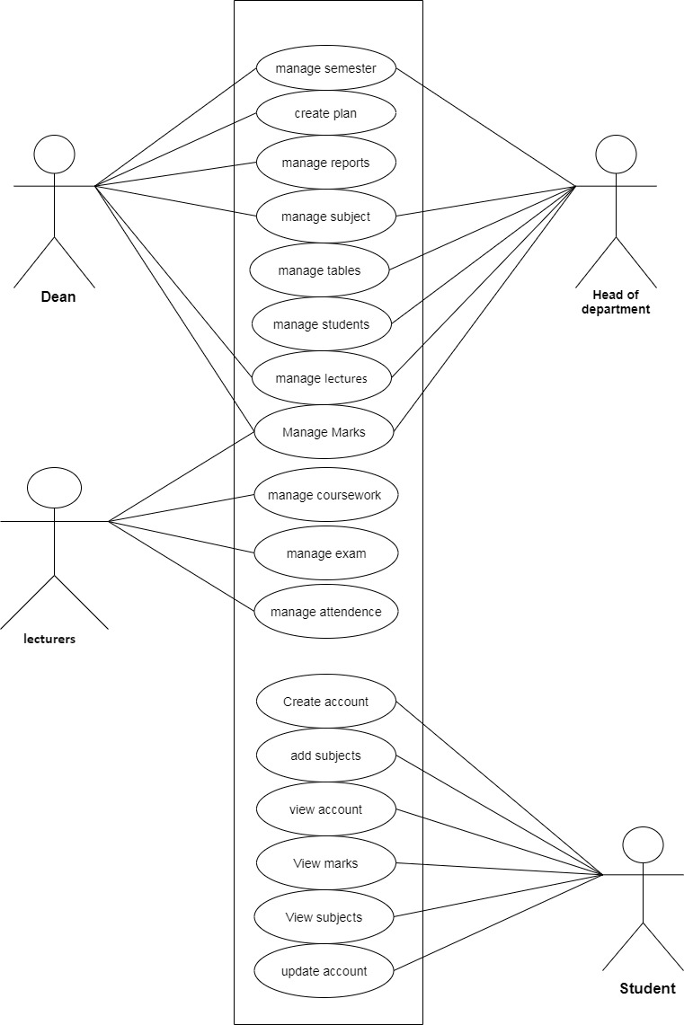

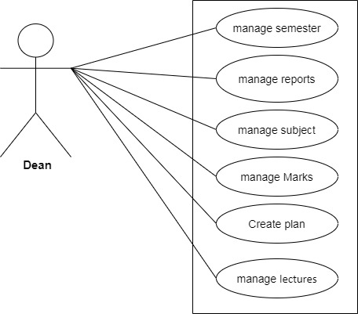

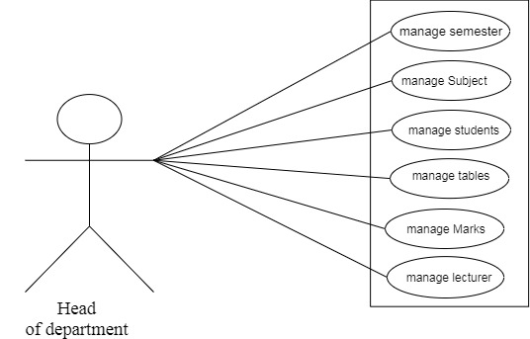

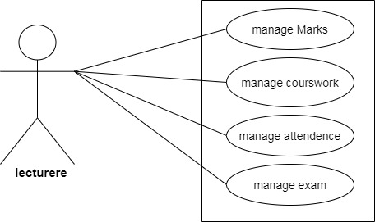

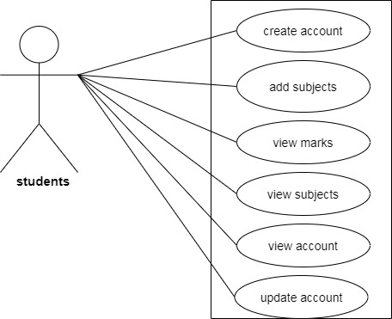

CRUD Table**:**

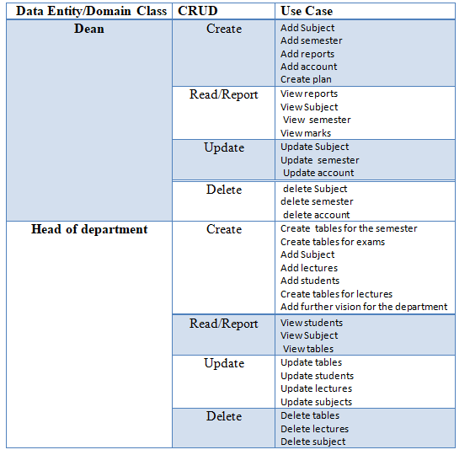

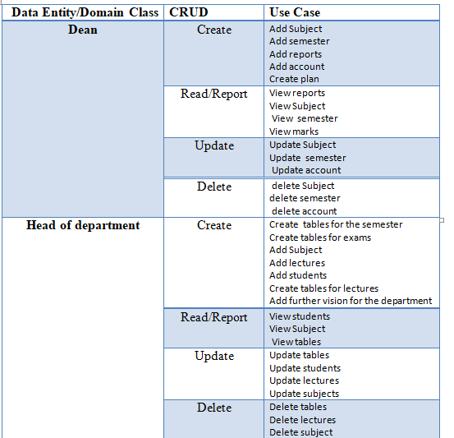

Use Cases Description:

|  |  |
| --- | --- |
| Use Case | Description |
| Add account | The dean enters a new account data. System creates a record of this account in the database |
| Delete account | The dean deletes an account. System drops its record from database |
| View account | The dean requests a course's content. System views course's details from database |
| Add subject | Head of department inters a new subject data. System creates a record of this subject in the database |
| Update subject | The head of department enters new values for existing data. System updates specified records. |
| Create table | The head of department enter new table each beginning of the semester. The system creates a record of this table in the database. |
| Update table | The head of department enters new values for existing data. System updates specified records. |
| Add mark | The lectures enter a mark of the student. System creates a record of this mark in the database |
| Update mark | The lectures enter new values for existing data. System updates specified records. |
| Delete mark | The lecture deletes a mark. System drops its record from database |
| Add report | Lecture or the head of department creates a report of its duties. System sends it to intended actor. |
| View report | The dean requests a course's content. System views course's details from database |

Event

**Is something that occurs at specific time and place, can be described, and should be remembered by the system.**

- Event:-

is something that occurs at specific time and place, can be described, and should be remembered by the system.

- External Event: -

1- Student wants to create account.

2- Student wants to add subject.

3-Student wants to view account, subject.

4- Student wants to view marks.

5- Student wants to update account.

6- Student wants to delete subject.

-Temporal Event:-

1- Produce table of the semester at the start of semester.

2- Produce table of exam after 8 weeks.

3- Produce table of lectures at begging of semester.

4-display mark exam after midterm.

5- View coursework at the end of semester.

6- Monthly report to student.

7- Monthly assignment at the determined date.

-State Event:-

1-Report to update attendance after 4 weeks.

2- Report to update semester when semester got updated.

3- Report to delete semester when semester got deleted.

4- Report to update account when account got updated.

5- Report to delete account when account got deleted.

Class diagram:

A class diagram in the Unified Modeling Language is a type of static structure diagram that describes the structure of a system by showing the system's classes, their attributes, operations (or methods), and the relationships among objects.

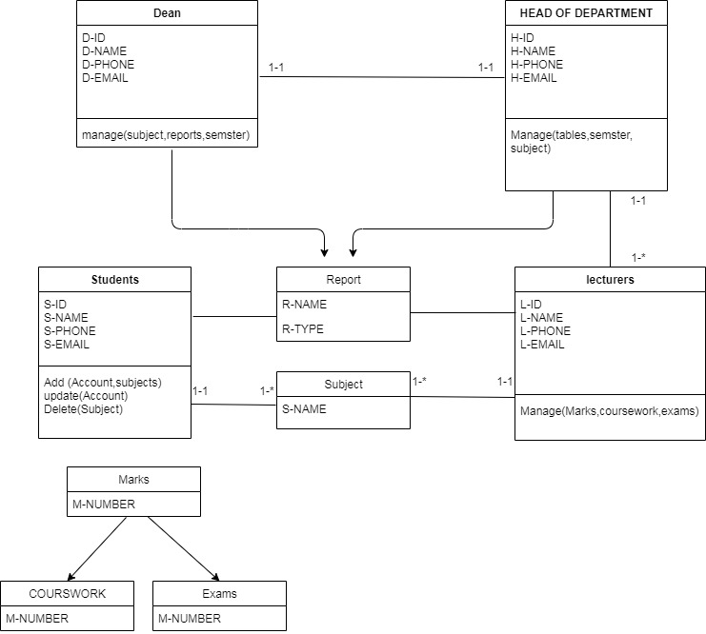

Entity and attribute:

Entity: a single unique object in the real world that is being mastered.

Attribute: a characteristic or trait of an entity type that describes the entity.

|  |  |
| --- | --- |
| Name of Entity | Definition |
| Dean | Which is responsible for every report. |
| Dean Id | Unique Id of Dean. |
| Dean name | Name of Dean that contact. |
| Dean phone | The phone number of Dean. |
| Dean email | Email that contact with Dean. |
| Head of department | Which is responsible for department of Dean. |
| Head of departments Id | Unique Id of Head of department. |
| Head of departments Name | Name of Head of department. |
| Head of departments phone | Phone number of Head of department. |
| Head of departments email | Email that connect of Head of department. |
| Lecturer | Which is responsible for student. |
| Lecturer Id | Unique Id of Lecture. |
| Lecturer name | Name of lecturer. |
| Lecturer phone | Phone number of lecturer. |
| Lecturer Email | Email that connect of lecturer. |
| Student | Which is learn in the University. |
| Student Id | Unique Id of student. |
| Student t name | Name of student. |
| Student phone | Phone number of student. |
| Student email | Email that connect of student. |
| Reports | Which is need to execute reports. |
| Report name | Name of report. |
| Report time | Which is time need to execute reports. |
| Subject | Which is what subject needed. |
| Subject name | Name of subject. |
| Marks | Which is needed to know about marks. |
| Marks number | Number of marks. |
| Course work | Which is needed to know about course work. |
| Midterm exam | Which is need to know about midterm exam.. |
| Final exam | Which is need to know about final exam. |

Use case brief description:

It is a document that explains the functionality of the system use cases.

## Create students marks:

## 

|  |  |  |
| --- | --- | --- |
| Use case name | Create student's marks. | |
| Scenario | Enter students marks. | |
| Triggering event | Lecture add students marks. | |
| Brief description | The lectures enter mark of the student . | |
| Actor | lecturer. | |
| Related use case | -- | |
| Stakeholders | Dean of the faculty head of department lecturers , student | |
| Precondition | Lecturers account. | |
| Post condition | Actors | |
| Flow of activities | **Actor** | System |
| 1) the lecturers open the add mark pages  3)the lecturer choose the add mark option  5)the lecturer choose student account  7)the lecturer adds the marks and submit them | 2)the system display the add mark option  4)the system show list of marks categories add  6)the system sets out students accounts that a lecturer is responsible  8)the system saves the marks |

### Delete subject:

|  |  |  |
| --- | --- | --- |
| Use case name | Create a students reports. | |
| Scenario | Delete a subject for student. | |
| Triggering event | Head of the department delete subject. | |
| Brief description | -----. | |
| Actor | Head of department . | |
| Related use case | none. | |
| Stakeholders | Dean- Head of department- lecturer- student. | |
| Precondition | Students must exit. | |
| Post condition | ----. | |
| Flow of activities | **Actor** | Head of department |
| 1) the headof department opens the delete subject page  3)the head of department choose the delete subject option  5)the head of department choose the subject that want delete. | 2)the system display the delete subject option.  4)the system show list of subject.  6)the system delete the subject that a lecturers select. |
| Exception condition | A Subject is take it or fail. | |

### Update report:

|  |  |  |
| --- | --- | --- |
| Use case name | Update report | |
| Scenario | Update report. | |
| Triggering event | User want to update report. | |
| Brief description | The dean enter new value for existing data. | |
| Actor | Dean . | |
| Related use case | Search of account report. | |
| Stakeholders | Dean- Head of department- lecturer- student. | |
| Precondition | Report must exit. | |
| Post condition | Report must print and send. | |
| Flow of activities | **Actor** | System |
| 1) open report page.  3the dean choose update report.  5)the dean update report. | 2)the system display report.  4)the system show the template of update report.  6)the system saves the change of report. |
| Exception condition | Report is missing. | |

## Create account:

|  |  |  |
| --- | --- | --- |
| Use case name | Create account | |
| Scenario | Create account. | |
| Triggering event | ----- | |
| Brief description | The dean enter new account for existing data. | |
| Actor | Dean . | |
| Related use case | Show marks, report, subject, tables. | |
| Stakeholders | Dean- Head of department- lecturer- student. | |
| Precondition | Account must exit. | |
| Post condition | ----- | |
| Flow of activities | **Actor** | System |
| 1) the dean choose add account.  3the dean enter the name that want to have account. | 2)the system display the add account option .  4)the system add the account. |
| Exception condition | -------- | |

Activity diagram

Activity diagram is another important behavioral diagram in UML diagram to describe dynamic aspects of the system. Activity diagram is essentially an advanced version of flow chart that modeling the flow from one activity to another activity.

### *Create account

##### 

### 

### 

### Update report: *

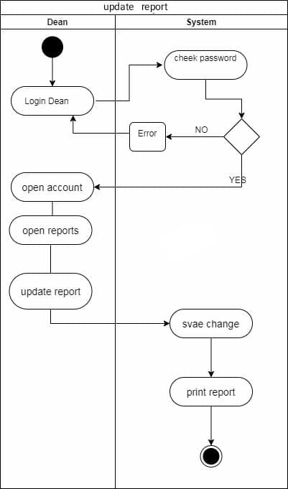

### 

### Delete subject:*

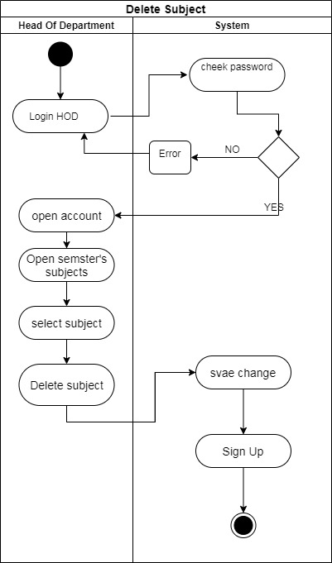

### Add student marks:

Challenges

The idea of ​​our system was to manage the tasks for the university departments. But we chose one of the departments, which is the engineering department, to implement our system on it, and then reflect it on the rest. We only found the head of the department for some reasons, so the analysis did not take much from us. We tried to target the largest amount of information from it.. And then we began to analyze based on the information we had from the interview and extracted the functions, non-functions. Also knowing the stakeholders of all kinds. What we felt we were really facing is the use and knowing all the functions of everyone in the department. And analyzing it and taking it to the class Diagram to find out the attribute and the verb. And then the activity diagram. Also, knowing every task when it begins, when it ends, and how it works was exhausting.. But we know that the success of any system starts from the analysis from scratch until its design on the ground. .and here we have completed the analysis stage. And we will face the design stage with every effort and perseverance.